Assignment – 1

Q1> Create the following tables with the given structures and insert sample data as specified:-
Ans> A) SALESPEOPLE;
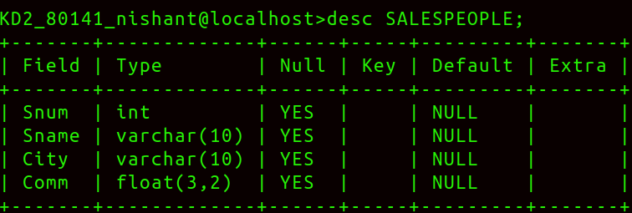
Inserted sample data in SALESPEOPLE;
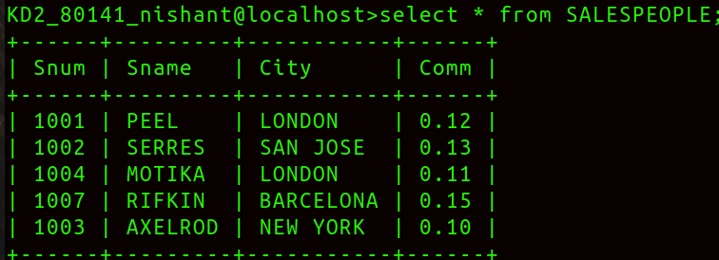
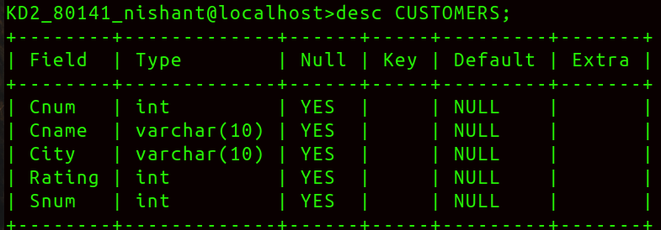
B) CUSTOMERS;
Inserted sample data in CUSTOMERS;
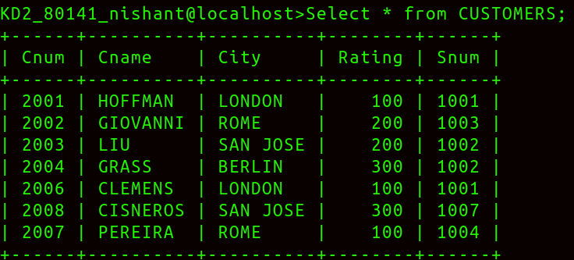
C) ORDERS;
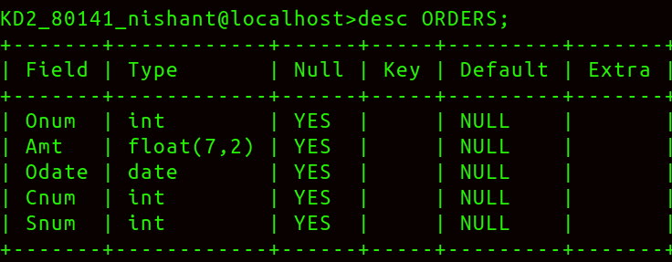
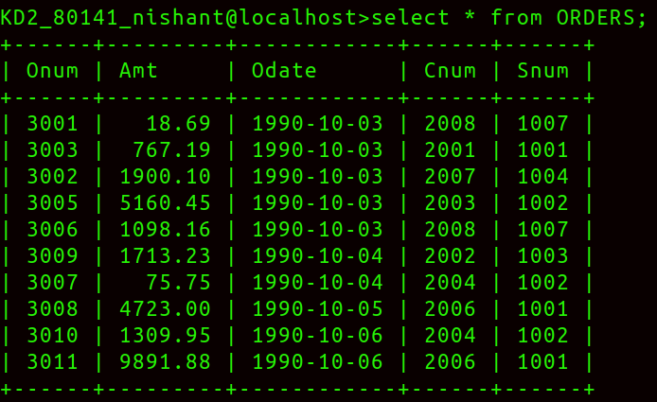
Sample data entered in ORDERS;

